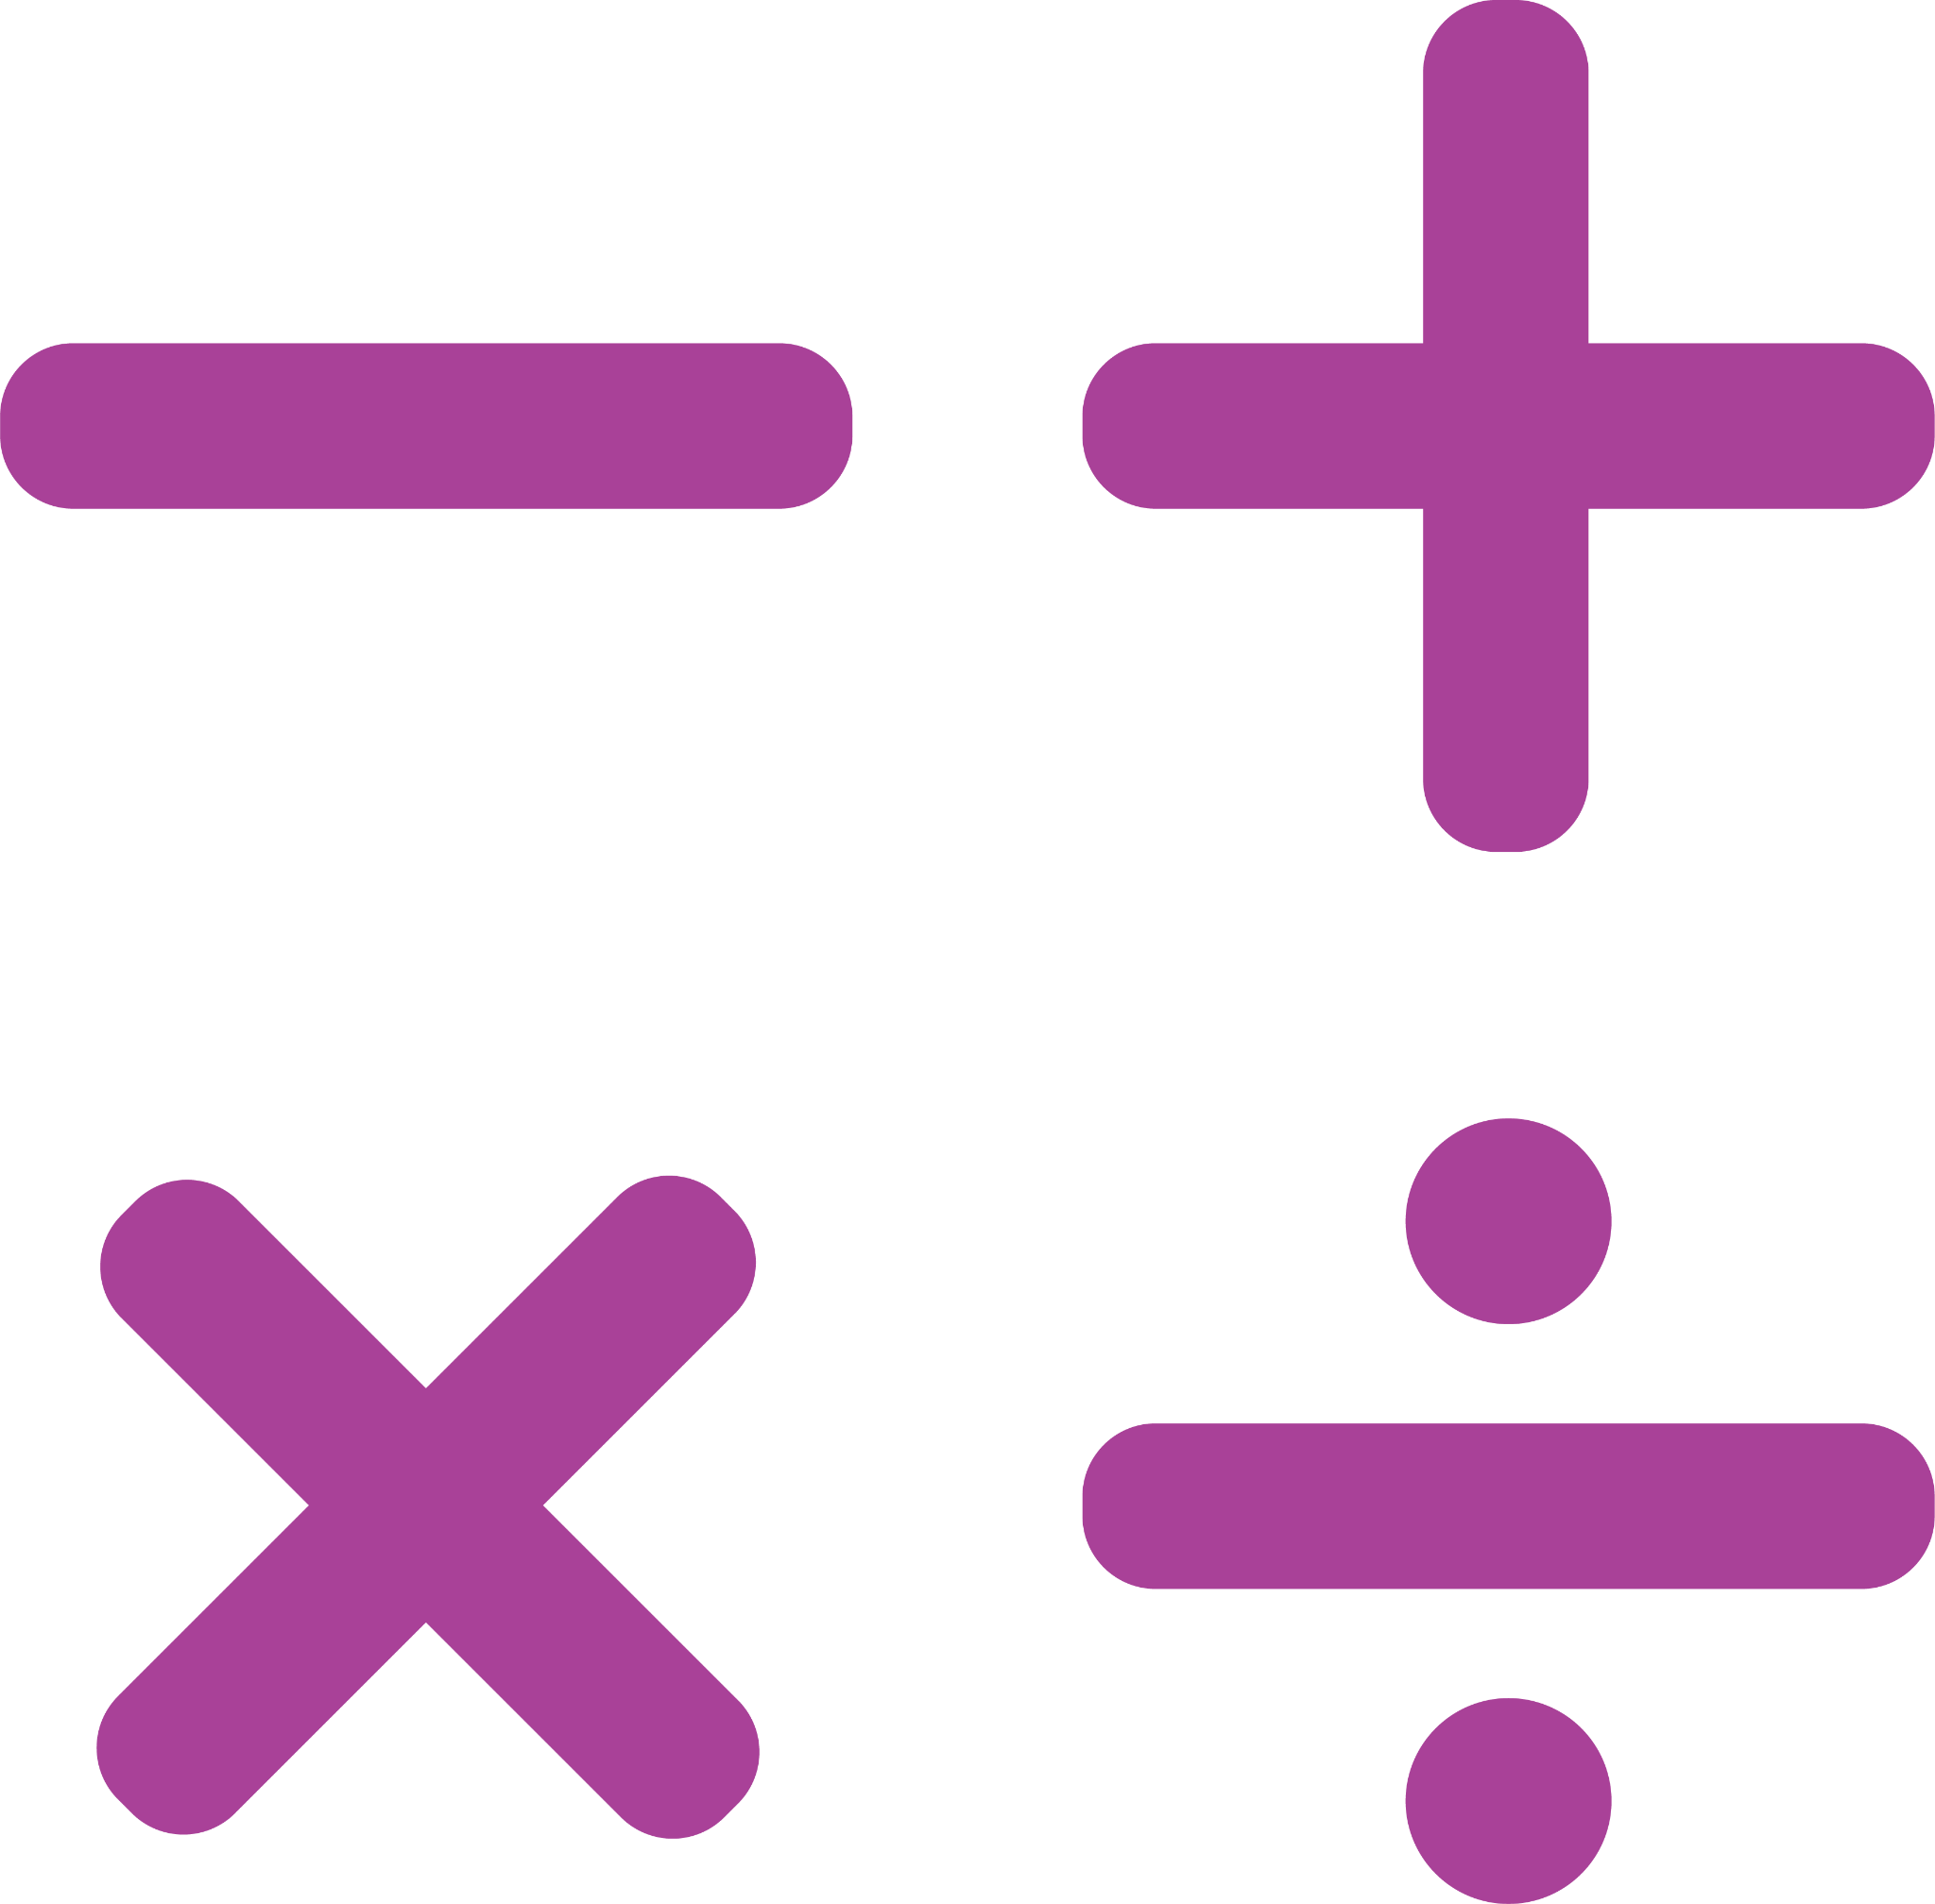
ANTICIPATION GUIDE
NAME: |  | DATE:

TOPIC: LINEAR, QUADRATIC, AND EXPONENTIAL MODELS
Read each statement below. Check the appropriate box to indicate whether you agree or disagree with the statement. After reading the assigned text, indicate whether you still agree or disagree with the statement. Then support your response by writing down information from the text.

Statement/Question | Before Reading | After Reading | Support in Text
1. Linear models have a constant rate of change. | - ☐ Agree  - ☐ Disagree | - ☐ Agree  - ☐ Disagree
2. Quadratic models have a parabolic shape. | - ☐ Agree  - ☐ Disagree | - ☐ Agree  - ☐ Disagree
3. Exponential models always start at a value of 0. | - ☐ Agree  - ☐ Disagree | - ☐ Agree  - ☐ Disagree
4. Linear models have an $y = mx + b$ equation form. | - ☐ Agree  - ☐ Disagree | - ☐ Agree  - ☐ Disagree
5. Quadratic models have an $y={ax}^{2}+bx+c$ equation form. | - ☐ Agree  - ☐ Disagree | - ☐ Agree  - ☐ Disagree
6. Exponential models have an $y={ab}^{x}$equation form. | - ☐ Agree  - ☐ Disagree | - ☐ Agree  - ☐ Disagree
7. Linear models can never have a y-intercept that is not 0. | - ☐ Agree  - ☐ Disagree | - ☐ Agree  - ☐ Disagree
8. Quadratic models are always increasing or decreasing. | - ☐ Agree  - ☐ Disagree | - ☐ Agree  - ☐ Disagree
9. Exponential models always have a positive rate of change. | - ☐ Agree  - ☐ Disagree | - ☐ Agree  - ☐ Disagree
10. Linear, Quadratic and Exponential models are the only types of models. | - ☐ Agree  - ☐ Disagree | - ☐ Agree  - ☐ Disagree

