DATA DRIVEN DIALOGUE
This protocol facilitates discussion focused on data sets, eliminating hunches and guess work and grounding the discussion in the raw data in order to examine patterns, associate cause and effects, and identify the sources of trends.

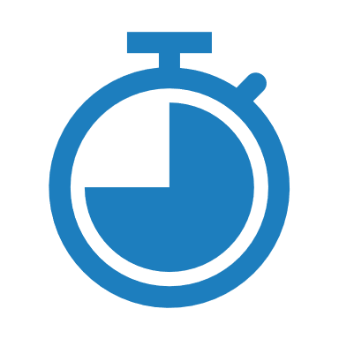Time: 60-90 minutes.
 Material: A data set.
Roles: Facilitator/timer (who also participates)

Directions
- Review the protocol as a group
- Facilitator gives a short overview of the data and provides context for discussion. Participants should be familiar with the source of the data set.
- Phase 1: Predictions – 5 minutes
  - Individually record preliminary predictions before examining the data in depth. Focus on using background knowledge and identifying surface level assumptions and predictions.
Ex. I predict____. Some possibilities are____. I assume____.
  - Each group member shares one prediction with the group. This should only take 3-5 minutes total.
- Phase 2: Observations – 15 minutes
  - Each person studies the data privately and records their data driven observations without explanations or conclusions.
  - Avoid preemptive analysis or inferencing and using language like “because” and “therefore”, instead ground all observations in the data and observed trends.
Ex. I count ____. A pattern I’ve discovered ____. 90% of the data points are ____.
- Phase 3: Observations Dialogue – 10 minutes
  - In small groups share and compare observations from phase 2, again avoiding drawing conclusions or conjecture.
- Phase 4: Inference Dialogue – 15 minutes
  - In small groups begin drawing conclusions from the observations, identifying possible causes for trends and patterns in the data, and discussing solutions/responses in context.

Ex. I think this pattern suggests ____. I think____ has a strong effect on____ because____.
  - Discuss additional data sets that could confirm or refute these inferences or track future changes/solutions/responses.
- Phase 5: Entire Group Discussion – 20 minutes
  - As a complete group share inferences discovered and discussed in phase 4, identify the main focuses and most important patterns and trends, and discuss findings in context.
  - Discuss changes/reactions/solutions that could alter the results.
  - Discuss concluding questions.
Ex. How might we share our findings with others? What were the goals of this data set and how effective is it? What else do we need to know and how can we find it out?
- Debrief the discussion protocol – 3 to 5 minutes

