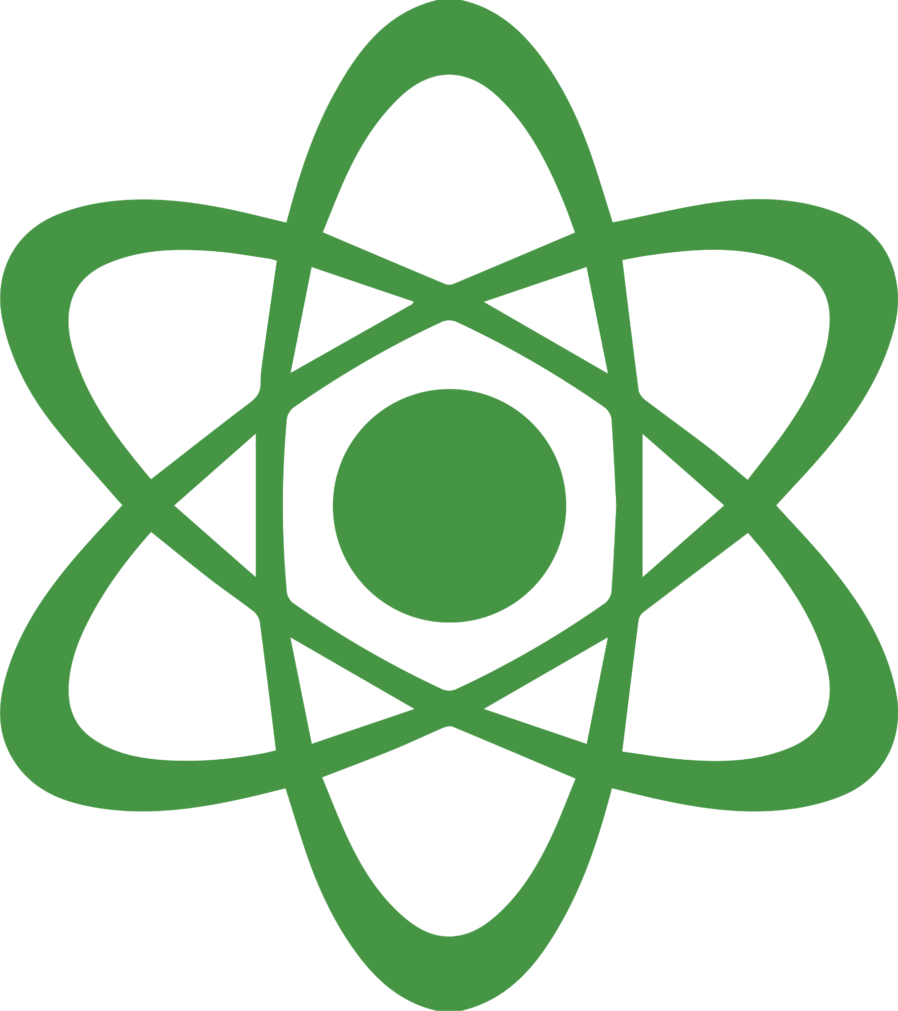
TEXT TREASURE HUNT
NAME: |  | DATE:

TOPIC: NERVOUS SYSTEM
Find different elements of the text.
1) Text elements: Write down the name of the chapter/book and two headings you thought were the most interesting.
2) Visual elements (pictures, figures, maps, etc.): Draw and describe the two visual elements you thought were the most interesting.
3) Reflect and summarize: Flip through the book/chapter. What is it about and is there something that seems challenging?

Text Element | Titles | Page #
Chapter Title | Chapter 3: Nervous System | 55
Most Interesting Heading | A Nerve Sends and Receives Information | 59
2nd Most Interesting Heading | Sensory Receptors and Pathways | 62

Most Interesting Visual Element
Draw it | Describe it

Summarize: Write a short summary about the text

Challenge: Write something you did not know before reading the text or something that was challenging

